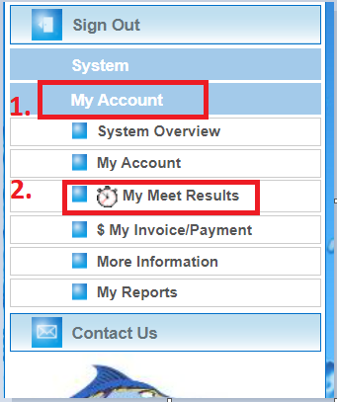

From the home page of the Team website, click
My Account
My Meet Results
If you have only one swimmer, you will see a page that looks like the one shown below. This view groups times by meet, with the most current meet first.

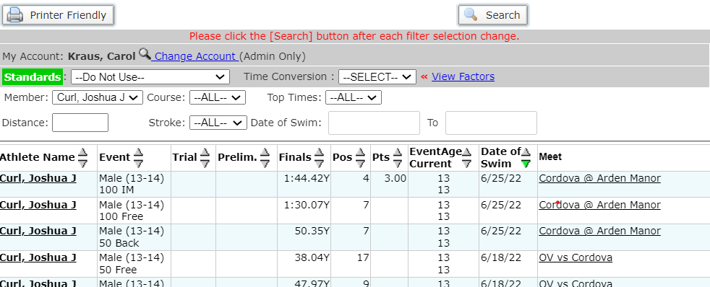

If you have more than one swimmer, you will use the drop-down option in the member box to select the swimmer that you want to review times for.

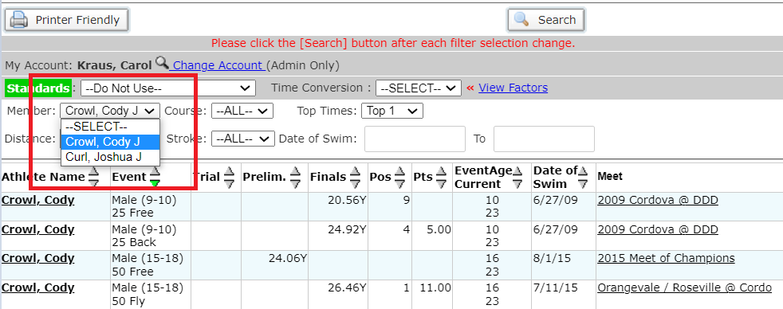

To display the best time for your swimmer in each event, you can select “Top1” in the Top Times drop down menu and press search. You can also change the order of most columns but using the arrows (circled below) to change the priority.
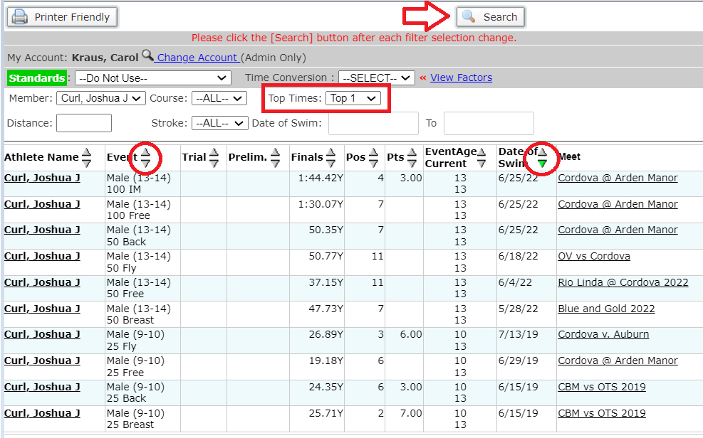
One of my favorite things is to see how my swimmer’s time has improved in an event throughout the seasons.

